*****TOM* PALMER**

**Book Signing Suggestions**

**October 2024 onwards**

1. Tips for schools
2. Letter & form to send home (overleaf)

**1 Tips for schools**

Children can be thrilled to have the opportunity to buy their own signed and personalised book by an author they have met.

I am very happy to work with **your local bookseller** but if you do not have one, Rosie Hill is our recommended independent book seller, with over 20 years experience of selling to schools. She offers competitive 20% discounts on all books, free next day delivery (orders over £50) and can advise on buying fiction and non fiction books. Contact Rosie Hill www.rosemaryhillbooks.co.uk email [rosie@rosemaryhillbooks.co.uk](mailto:rosie@rosemaryhillbooks.co.uk) or phone 01580 879560 or 07906 776681.

Rosie offers an **author visit** **book box service** to schools (with free delivery and free returns) where she sends you a box of my books, specially selected based on her experience of quantities of what is currently selling best for each age group. **Book sales through Rosie can then be offered for sale at 99p discount to your pupils**. Pupil payments need to go to the school and then Rosie is paid for all the books afterwards by the school.

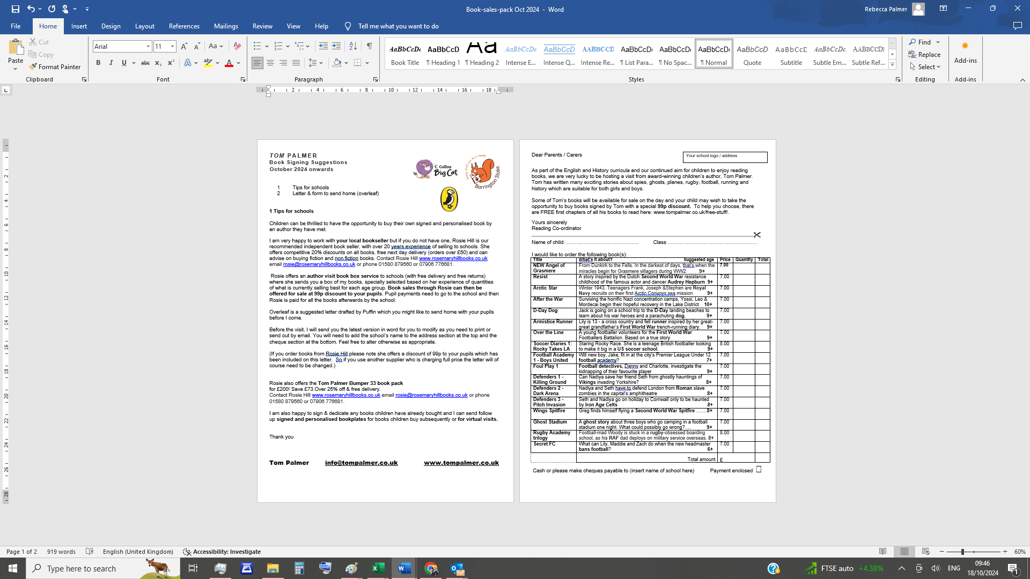

Overleaf is a suggested letter drafted by Puffin which you might like to send home with your pupils before I come.

Before the visit, I will send you the latest version in word for you to modify if you need to print it or send out it by email. You will need to add the school’s name to the address section at the top and the cheque section at the bottom. Feel free to alter otherwise as appropriate.

(If you order books from Rosie Hill please note she offers a discount of 99p to your pupils which has been included on this letter. So if you use another supplier who is charging full price the letter will of course need to be changed.)

Rosie also offers the **Tom Palmer Bumper 33 book pack**

for £200! Save £73.Over 25% off & free delivery.

Contact Rosie Hill www.rosemaryhillbooks.co.uk email [rosie@rosemaryhillbooks.co.uk](mailto:rosie@rosemaryhillbooks.co.uk) or phone 01580 879560 or 07906 776681.

I am also happy to sign & dedicate any books children have already bought and I can send follow up **signed and personalised bookplates** for books children buy subsequently or **for virtual visits.**

Thank you

Tom Palmer [info@tompalmer.co.uk](mailto:info@tompalmer.co.uk) [www.tompalmer.co.uk](http://www.tompalmer.co.uk)

Dear Parents / Carers

Your school logo / address

As part of the English and History curricula and our continued aim for children to enjoy reading books, we are very lucky to be hosting a visit from award-winning children’s author, Tom Palmer. Tom has written many exciting stories about spies, ghosts, planes, rugby, football, running and history which are suitable for both girls and boys.

Some of Tom’s books will be available for sale on the day and your child may wish to take the opportunity to buy books signed by Tom with a special **99p discount.** To help you choose, there are FREE first chapters of all his books to read here: [www.tompalmer.co.uk/free-stuff/](http://www.tompalmer.co.uk/free-stuff/).

Yours sincerely

Reading Co-ordinator

----------------------------------------------------------------------------------------------------------------------------------------------------------✀

Name of child: …………………………………… Class …………………………………………….

I would like to order the following book(s):

|  |  |  |  |  |
| --- | --- | --- | --- | --- |
| **Title** | **What’s it about? Suggested age** | **Price** | **Quantity** | **Total** |
| **NEW Angel of Grasmere** | **From Dunkirk to the Fells. In the darkest of days, that’s when the miracles begin for Grasmere villagers during WW2 9+** | **7.00** |  |  |
| **Resist** | A story inspired by the Dutch **Second World War** resistance childhood of the famous actor and dancer **Audrey Hepburn 9+** | 7.00 |  |  |
| **Arctic Star** | **Winter 1943.** Teenagers Frank, Joseph &Stephen are **Royal** **Navy** recruits on their first Arctic Convoys sea mission **9+** | 7.00 |  |  |
| **After the War** | Surviving the horrific Nazi concentration camps, Yossi, Leo & Mordecai begin their hopeful recovery in the Lake District **10+** | 7.00 |  |  |
| **D-Day Dog** | Jack is going on a school trip to the **D-Day** landing beaches to learn about his war heroes and a parachuting **dog. 9+** | 7.00 |  |  |
| **Armistice Runner** | Lily is 13 - a cross country and fell **runner** inspired byher great-great grandfather’s **First World War** trench-running diary. **9+** | 7.00 |  |  |
| **Over the Line** | A young footballer volunteers for the **First World War** Footballers Battalion. Based on a true story. **9+** | 7.00 |  |  |
| **Soccer Diaries 1:**  **Rocky Takes LA** | Staring Rocky Race. She is a teenage British footballer looking to make it big in a **US soccer school.** **9+** | 8.00 |  |  |
| **Football Academy 1 - Boys United** | Will new boy, Jake, fit in at the city’s Premier League Under 12 **football** academy?***7+*** | 7.00 |  |  |
| **Foul Play 1** | **Football detectives,** Danny and Charlotte, investigate the kidnapping of their favourite player **9+** | 7.00 |  |  |
| **Defenders 1 -**  **Killing Ground** | Can Nadiya save her friend Seth from ghostly hauntings of **Vikings** invading Yorkshire? **8+** | 7.00 |  |  |
| **Defenders 2 -**  **Dark Arena** | Nadiya and Seth have to defend London from **Roman** slave zombies in the capital’s amphitheatre **8+** | 7.00 |  |  |
| **Defenders 3 -**  **Pitch Invasion** | Seth and Nadiya go on holiday to Cornwall only to be haunted by **Iron Age Celts *8+*** | 7.00 |  |  |
| **Wings Spitfire** | Greg finds himself flying a **Second World War** **Spitfire** …….**8+** | 7.00 |  |  |
| **Ghost Stadium** | A **ghost story** about three boys who go camping in a football stadium one night. What could possibly go wrong? … **9+** | 7.00 |  |  |
| **Rugby Academy trilogy** | Football-mad Woody is stuck in a **rugby**-obsessed boarding school, as his **RAF** dad deploys on military service overseas. **8+** | 8.00 |  |  |
| **Secret FC** | What can Lily, Maddie and Zach do when the new headmaster **bans football**? **6+** | 7.00 |  |  |
|  | Total amount | £ | |  |

Cash or please make cheques payable to (insert name of school here) Payment enclosed 