**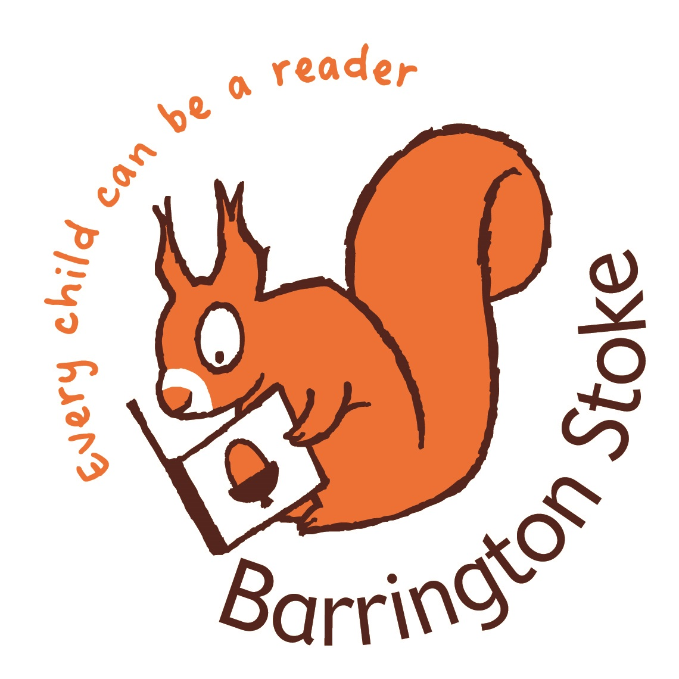***TOM* PALMER**

**Author Visit Guidelines**

1. Schedule
2. Library Books offer
3. Posters
4. Author Q&A
5. Powerpoint and Booklets
6. Author visits options:

A) Football Reading Game B) Rugby Reading Game or C) NEW Historical Fiction

1. Certificates
2. Press Releases

**1 Schedule**

* Before my visit we will have agreed arrival & departure times, the visit format and payment details.
* I had full CRB clearance until the scheme stopped. My most recent DBS Enhanced Certificate was issued 13 March 2018 no 001608245185. Current legislation does not allowed self- employed individuals to apply for a DBS check on themselves. I am happy for you to apply for a DBS check.
* I have £10 million public liability insurance.
* I am visiting you as a guest. Please have teacher *I* librarian cover provided for the duration of my visit.
* Author insurance is invalidated without the presence of a teacher *I* librarian.
* Covid 19 – I am happy to observe any extra precautions your school has put in place for visitors.

**2 Books Offer (see the Book Signing Suggestions sheet for more information)**

It's always more exciting for children if they have seen *I* read one of my books beforehand. For this reason I'd recommend getting copies for your class or library. There are free first chapters of all my books here: <http://tompalmer.co.uk/free-reads/>

Rosie Hill is our recommended independent book seller, with over 20 years’ experience of selling to schools. She offers **20% discounts on all** books, free next day delivery (orders over £150). Rosie also offers the **Tom Palmer Bumper 33 book pack** for £194! Save £63.Over 25% off & free delivery.

Contact Rosie Hill www.rosemaryhillbooks.co.uk email [rosie@rosemaryhillbooks.co.uk](mailto:rosie@rosemaryhillbooks.co.uk) or phone

01580 879560 or 07906 776681.

**Football History**

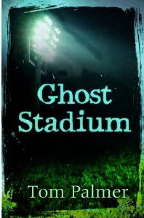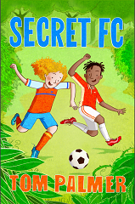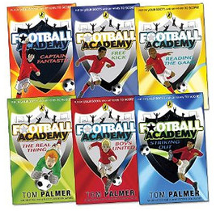

**Celts/Romans/Anglo-Saxons/Vikings**

**WW1**

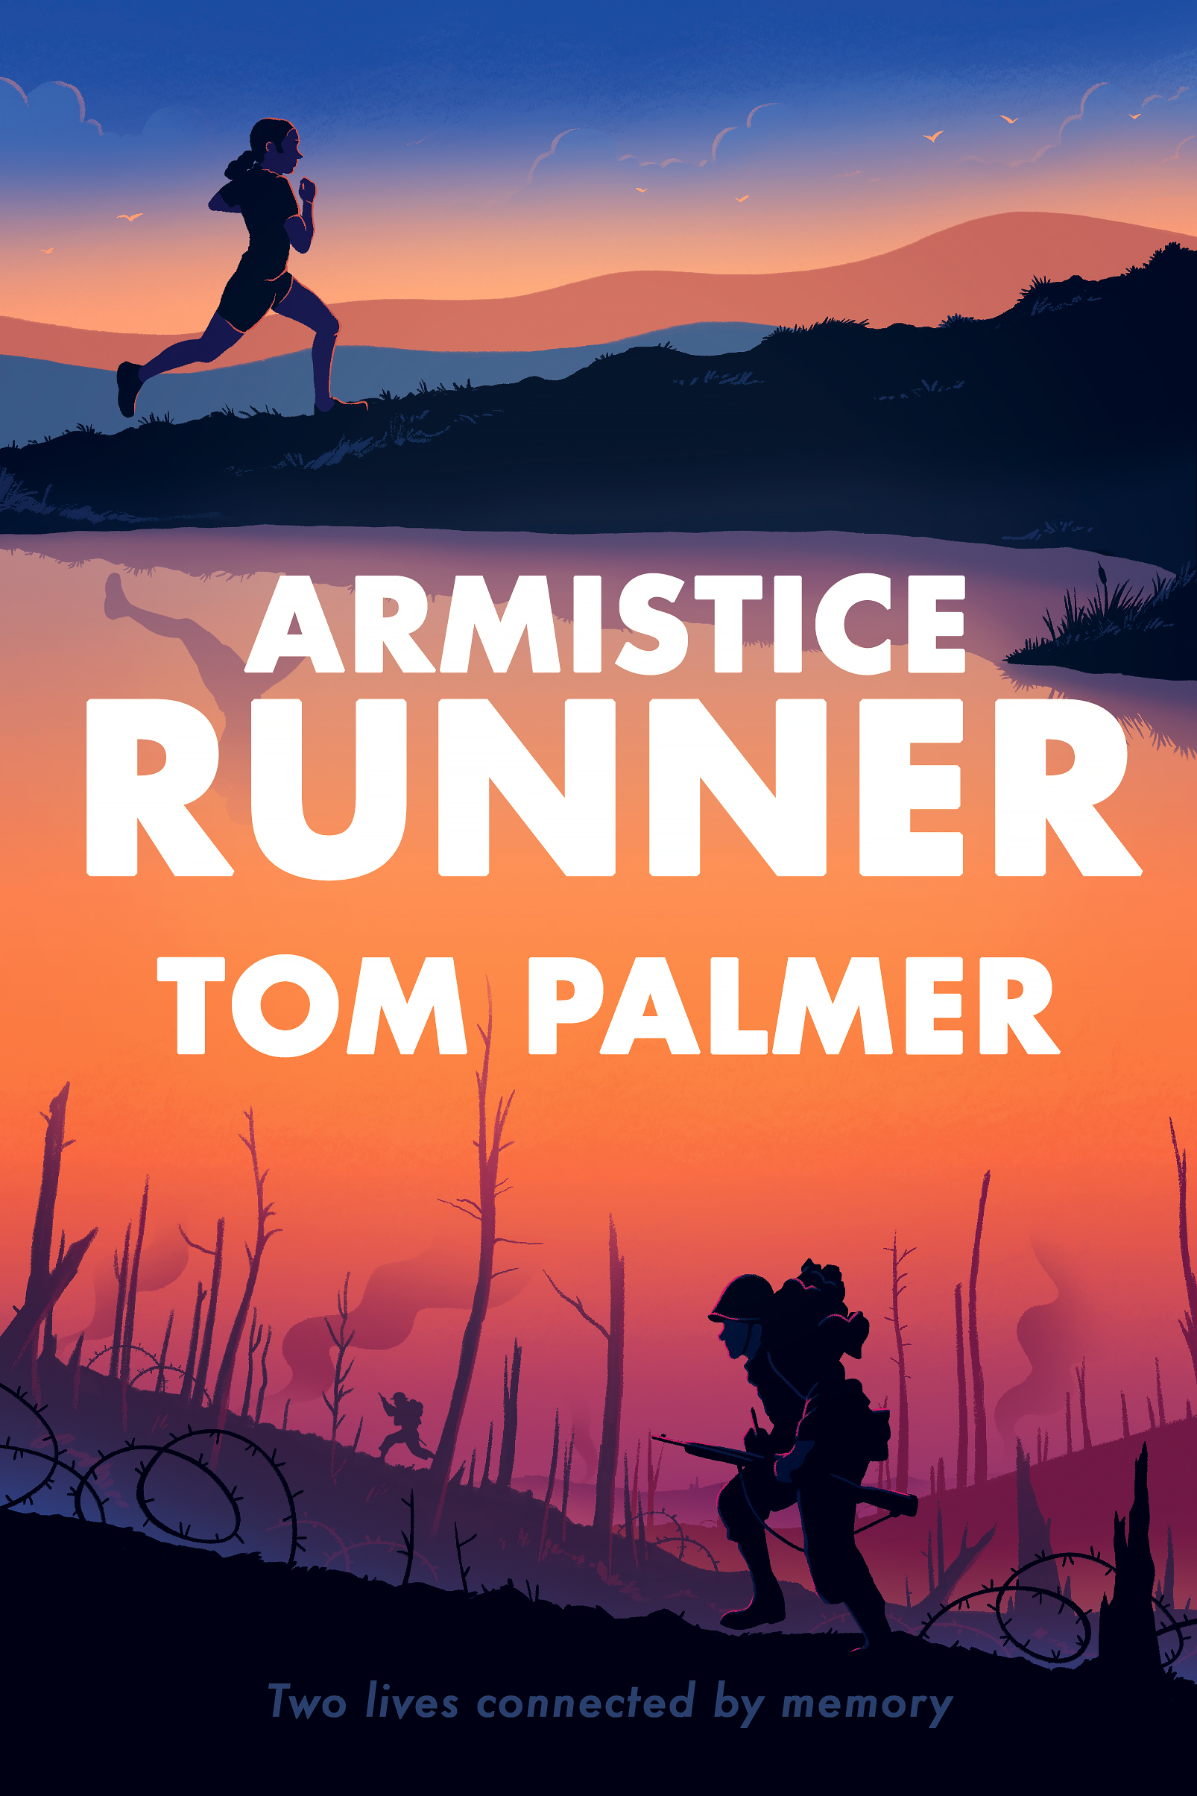

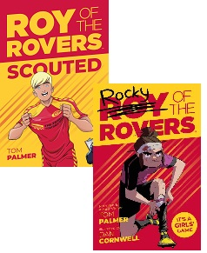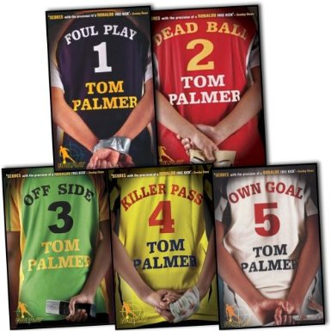

**OUT**

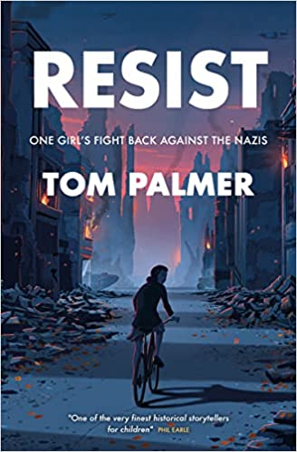 **WW2 MAY 2024**

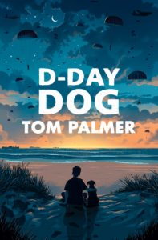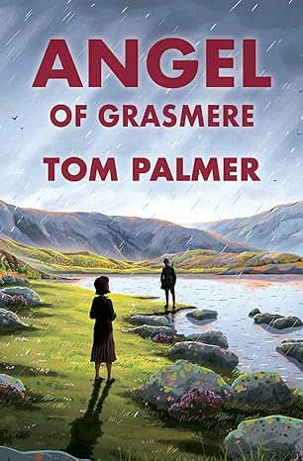

**Rugby**

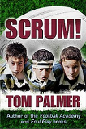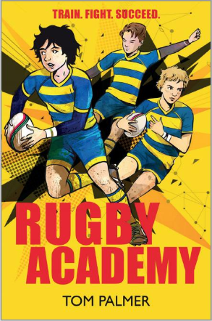

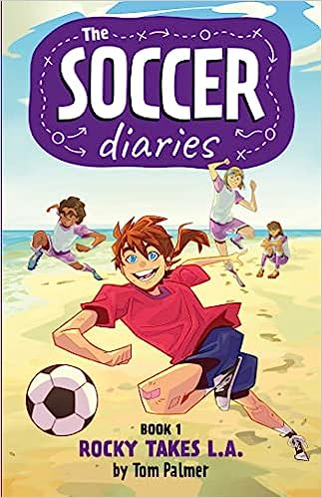

**Tom Palmer** [**admin@tompalmer.co.uk**](mailto:admin@tompalmer.co.uk)[**www.tompalmer.co.uk**](http://www.tompalmer.co.uk)

**3 Posters**

I enclose a selection of posters to put up beforehand on your school front door, in class and in the PE changing rooms, sports hall or your library. Pupils may also like to design their own posters to advertise the visit or make bunting. You can use additional posters and book cover images off here … [www.tompalmer.co.uk/posters/](http://www.tompalmer.co.uk/posters/)

**4 Author Q & A**

I always make time to answer children's questions about how I write and about my books. I   
recommend using some class time to visit beforehand to really make the most of the experience of   
meeting an author. There are lots of free stories, interviews and photos on my website. It might be   
useful for your pupils to read [www.tompalmer.co.uk/biography/.](http://www.tompalmer.co.uk/biography/.)

Go to [www.tompalmer.co.uk/schools-librarians/literacy-resources](http://www.tompalmer.co.uk/schools-librarians/literacy-resources) for free resources including a website quiz to encourage pupils to navigate around a website and find out more about me and my books.

**5 Powerpoint and souvenir booklets**

Before my visit we will send you a powerpoint and a printable souvenir booklet with fun activities and spaces to write down their question to ask me and to collect my signature if they should wish.

Virtual visits – I can send signed stickers with my signature on to be added by hand

**6 Author visits options:**

Please do let me know if you'd prefer a particular focus on rugby / football / historical fiction writing / Fair Trade. For a full list of workshops I can deliver please see . [www.tompalmer.co.uk/wp-content/uploads/2020/06/Tom-Palmer-Virtual-WORKSHOPS.pdf](http://www.tompalmer.co.uk/wp-content/uploads/2020/06/Tom-Palmer-Virtual-WORKSHOPS.pdf). A brief summary follows:

**A) Football Reading Game B) Rugby Reading Game**

My trademark visit is a fun and interactive reading quiz about rugby or football through newspapers, magazines, non-fiction and fiction. The winning team *I* player wins is awarded a trophy. Pupils are encouraged to read around their chosen sport in the week ahead of my visit to help them win the trophy. If they'd like to practice taking penalties that might help them too!

**C) Historical Fiction author visits.**

I am the RAF Museum's Writer in Residence and my books feature key KS2 & 3 history periods:

* **Iron Age Celts - Read *Defenders: Pitch Invasion*
* Roman Britain - Read *Defenders: Dark Arena*
* Anglo-Saxons *I* Vikings - Read *Defenders: Killing Ground*
* First World War - Read *Flyboy*, *Over the Line* & *Armistice Runner*
* Second World War - Read *Spitfire, D-Day Dog*, *Arctic Star, After the War,*

*Resist* and coming May 2024 *Angel of Grasmere*

**D) Creative Writing** with an option to explore what I am currently writing

* ideas and planning
* drafting and editing
* researching & writing about history

**7 Certificates**

Please tell me if any pupil reads a series so I can give them a signed certificate on the day or by post.

**8 Press release**

This is a good PR opportunity for your school. Encourage your pupils to engage with their local media by writing a press release to send to the local newspapers and radio. First News, the national children's newspaper are always looking for interesting stories. Email [newsdesk@firstnews.co.uk and](mailto:newsdesk@firstnews.co.uk%20and%20) you'll get a copy of the newspaper if they print your story.

**Tom Palmer** [**admin@tompalmer.co.uk**](mailto:admin@tompalmer.co.uk)[**www.tompalmer.co.uk**](http://www.tompalmer.co.uk)