School address
School address
School address
School postcode

Date

Dear Parent

Use the World Cup to get your children reading for pleasure

Many children struggle to enjoy reading. Sometimes the only thing they will read about is their number one passion. During June and July the World Cup is going to capture their imaginations. So, if your family love football, here are five tips on how to use that excitement to help your children enjoy reading for pleasure. It doesn’t matter what they read, ALL READING IS GOOD!

One. Invest in one of the special World Cup editions of the football magazines, packed with facts, photos and player interviews. Check out magazine stands for Match, Match of the Day, Kickaround, FourFourTwo and World Soccer. Keep it in the TV room to read during the breaks.

Two. On the day after a big game deliver a newspaper to your child’s room, so they can read match report and look at the statistics and photos.

Three. Some children dislike fiction and prefer non-fiction. Check out the new football biography series for children, Ultimate Football Heroes, featuring lots of player from this World Cup and from the past. Available at bookshops, online and in libraries.

Four. If your children do like fiction, there are lots of football story authors. Have a look for Helena Pielichaty (7+), Bali Rai (7+), Dan Freedman (9+), David Bedford (5+), Tom Palmer (6+ to 11+) and Mal Peet (11+).

Five. If you have a computer or tablet, keep the BBC World Cup page open all the time, so that children can check the very latest news. www.bbc.co.uk/sport/football/world-cup

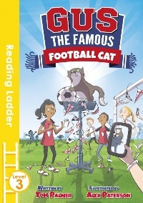
Finally, enjoy the World Cup and all the fantastic things there are to read about it.

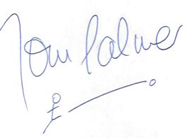
Best wishes

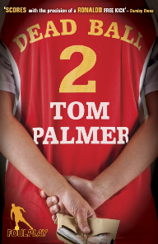
Tom Palmer
www.tompalmer.co.uk

Tom has written over 40 books for children including two World Cup books. Gus the Famous Football Cat (aimed at ages 5 to 8) is about a cat that can predict football results at this year’s World Cup final. Dead Ball (age 9 to 13) is a football thriller set in Moscow, Russia.

