For Football Academy readers…  when a pupil finishes a book (or their  target) start with giving them the lowest football league sticker - League Two, then continue upwards, League One, the Championship, the Premier League, the Champions League and the World Cup. | For Foul Play readers (there are fewer in the series), when a pupil has finished a book (or their target) start with giving them the lowest football league sticker - League One, then continue upwards, the Championship, the Premier League, the Champions League and the World Cup. | Football Academy 7+  Foul Play 9+  The different levels that footballers reach are matched in these reading success levels for pupils.  Labels can be printed on to J8160 or L7160 (21 a sheet 63.5mm x 38.1mm)
I am a League Two reader | I am a League One reader  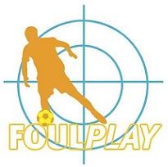
I am a League One reader | I am a Championship reader
I am a Championship reader | I am a Premier League reader
I am a Premier League reader | I am a Champions League reader
I am a Champions League reader | I am World Cup Finals reader
I am World Cup Finals reader

