2012
Tom Palmer

Ten chances PLRS would have given me

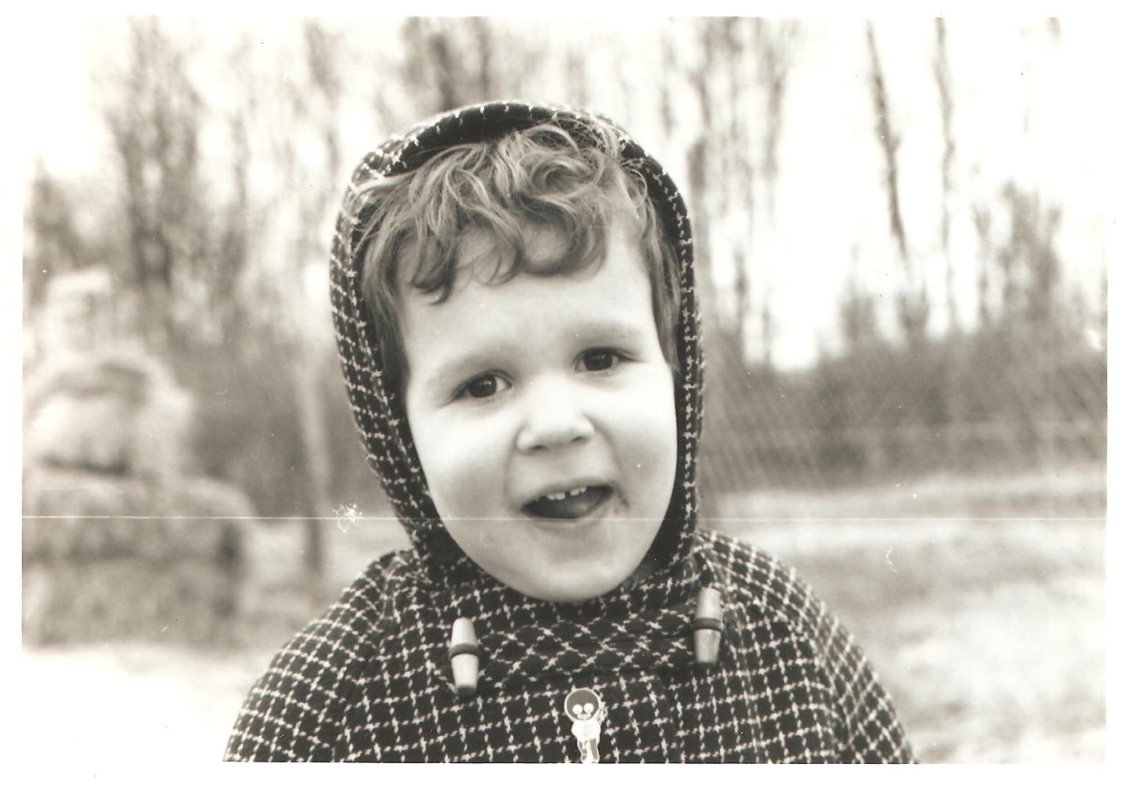

Good luck to all the pupils, teachers and librarians taking part in this year’s Premier League Reading Stars. I wish I could have taken part in something like this when I was young. I wasn’t a keen reader, but thankfully my mum used my love of football to get me into reading. I’m now the author of fourteen children’s football novels for Puffin Books.

Ten chances Premier League Reading Stars would have given me.
Tom Palmer

1 When I was seventeen, I was amazed to discover that there were books about Leeds United.
PLRS introduces children to a wide range of books.

2 I worshipped footballers, but I never saw one holding a book, let alone talking about how much they liked it.
PLRS uses footballers as role models to encourage football fans to read.

3 I talked about football with my friends all day. We did not talk about books. I never knew that several of them read books for fun.
PLRS encourages children to talk about their reading passions in front of each other.

4 I started reading because I was passionate about football, not because I wanted to pass exams or because I liked reading.
PLRS enthuses children to read for pleasure alone – through their love of football.

5 I thought that, because I could never finish a book, it confirmed that I was stupid. I never thought it could just be the wrong book for me – or even a badly written book.
PLRS gives children the confidence to making positive reading choices.

6 I could never have read a whole book until I had built up my stamina reading about football in newspapers and magazines.
PLRS promotes reading websites, newspapers, magazines, fiction and non-fiction, all as valid reading material.

7 I was too scared to go into real bookshops. I thought I would be kicked out because I didn’t belong there. So I used to buy books in WHSmith, because, if caught, I could claim that I was there for a biro or pencil for school.
PLRS encourages teachers and librarians to take children into bookshops.

8 I used to go to the library at 9 a.m. on a Saturday because I knew there was only one librarian on duty. Then I would be less likely to have to answer any questions they might ask me.
PLRS gets children to enjoy visiting libraries and to feel comfortable in them.

9 I never imagined that reading would give me confidence, would help me talk to girls, would let me see things from other people’s points of view, would help me make less mistakes, would make me happier for life.
PLRS intends to create readers for pleasure for life.

10 Until I met authors I never dreamed I could be one myself. I thought that normal people couldn’t do jobs like that.
PLRS gives schools and libraries advice on arranging author visits.

Tom is the author of fourteen football books, all published by Puffin Books. His new book – The Squad: Black Op, based in Krakow just before Euro 2012 – is published by Puffin in May 2012.
www.tompalmer.co.uk

